Headington Road and London Road transport improvements:

Background and strategy

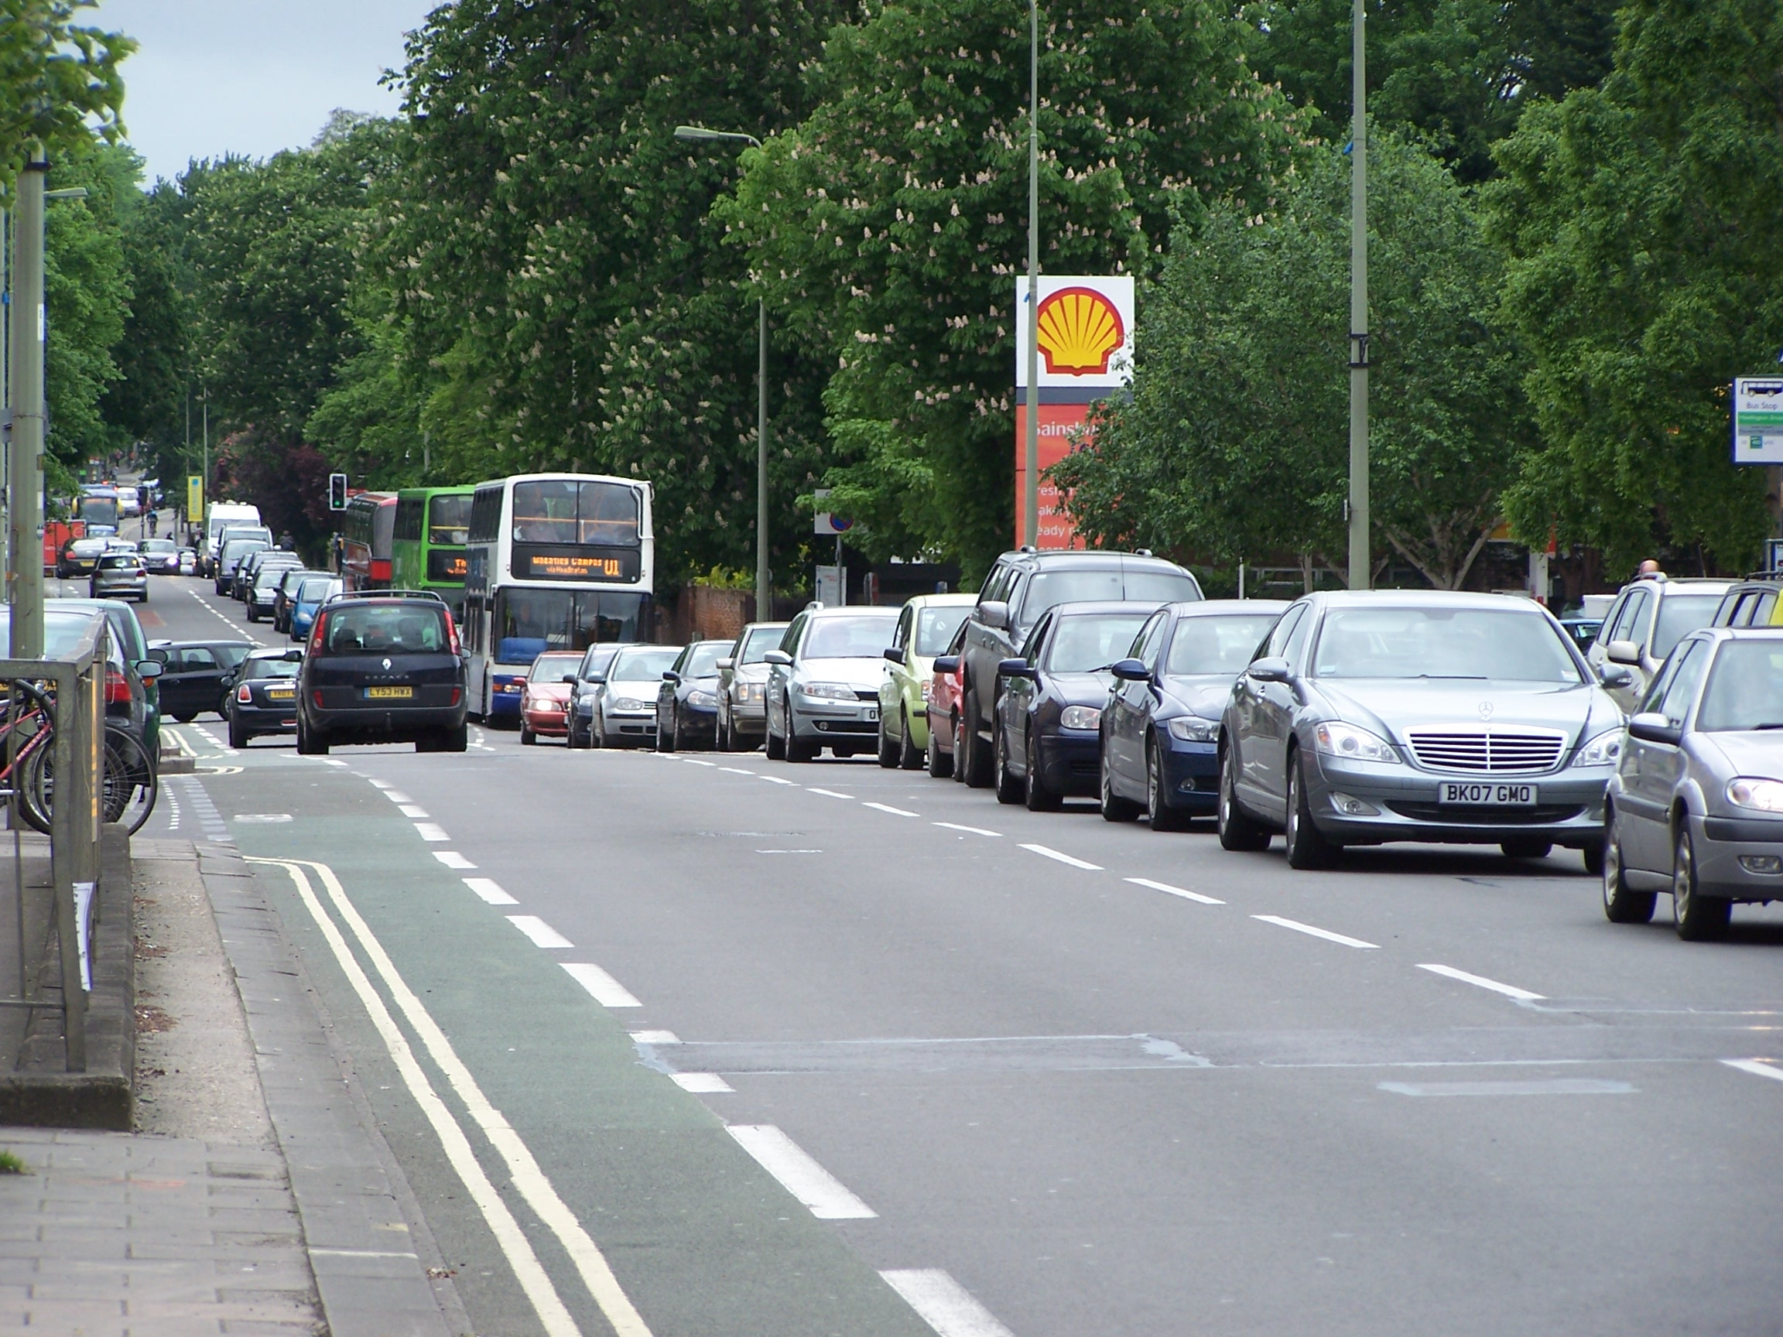

July 2007

Introduction

This booklet provides details on the background and strategic context of the proposals for improvements to Headington Road and London Road which are the subject of consultation in July 2007. It sets out the background to the county council’s transport strategy for Headington in general and our strategy for Headington Road and London Road in particular.

The plans have been developed to make bus journeys quicker and more reliable, to enhance the Headington shopping area and improve road safety for all users.

Background context

Headington has seen more growth in employment than any other part of Oxford in recent years. The expansion of hospital services has been particularly rapid, and Oxford and Oxford Brookes Universities are also growing in Headington.

Available land is very scarce in Oxford, and if the city is to continue to compete nationally and internationally as a centre of excellence for health and education, any appropriate opportunities for development in Headington should be taken. Both Oxfordshire County Council and Oxford City Council have therefore supported carefully planned development in Headington in support of general economic growth.

In transport terms, Headington is a good place for employment and services: it is well situated in relation to the city’s population and main bus routes, so many people who need to come to Headington can walk, cycle or use the bus to get here.

However, despite the benefits that this growth brings to the city’s economy, the problems and challenges that come with the growth are all too clear. The new attractions in Headington draw more people into the area, and for many people the car is still the most attractive option for their journey. As a result, traffic is growing in parts of Headington, leading to increased congestion, pollution, and safety problems.

The Transport strategy for Headington

For a number of years, Oxfordshire County Council’s transport strategy for the Headington area (formerly known as HAMATS or Headington and Marston Area Transport Strategy) has consisted of a range of different elements. It will continue to do so for at least the foreseeable future. Our aim has been to allow increasing numbers of people to travel to and through Headington safely, reliably, and with a minimal impact on the environment. This cannot be achieved by creating more capacity for increased car traffic in Headington, so our strategy has been and will continue to be to make access by ways other than the car as attractive as possible relative to the car.

This includes:

- Making bus services (the most likely alternative to the car for many) as convenient and reliable as possible
- Introducing controlled parking zones to prevent free commuter parking in residential streets close to the area’s employment sites
- Encouraging car traffic to use the ring road, through signage and infrastructure improvements
- Providing new cycle and pedestrian infrastructure to make walking and cycling safer and more convenient
- Expanding and enhancing Oxford’s Park & Ride system
- Working with Oxford City Council to limit the number of parking spaces permitted at new developments
- Working with existing employers to restrict and charge for parking at their sites.

Recent examples of schemes implemented as part of this strategy include:

- The introduction of a number of controlled parking zones in residential streets in Headington and Marston, removing hundreds of free unofficial commuter parking spaces and prioritising the available parking for residents
- The opening of the Osler Road and Saxon Way bus links, which have cut journey times, improved reliability and helped improve the frequency of services on the routes to and from the JR hospital, elsewhere in the local area
- The installation of new cycle and pedestrian crossings in the area – two on Headley Way, one on Old Road, conversion of a Pelican to a Toucan crossing on London Road near Latimer Road. These have enabled improvements to cycle and pedestrian links in the area and beyond
- The major improvement of the Headington roundabout completed in December 2006.

The county council is committed to continuing to work on delivering further transport improvements in the area in addition to the proposed changes to the Headington Road and London Road on display at the exhibition.

The strategy for Headington Road and London Road

Headington Road and London Road are central to Headington’s transport network, and one of the most important parts of the city’s network as a whole. It is used by tens of thousands of people per day – from local residents walking to the shops to people commuting into London. It therefore has a major part to play in our transport strategy for Headington and for Oxford.

Our objectives for Headington Road and London Road are to:

- Make bus journeys quicker and more reliable
- Enhance the Headington shopping area
- Improve road safety for all road users

To achieve these objectives, our proposed strategy is:

- To pursue all the elements of our wider transport strategy for Headington outlined above to tackle traffic growth on Headington Road and London Road and in the surrounding area
- To create bus lanes to allow buses to by-pass congestion
- To use traffic lights to give buses greater priority
- To introduce 20 mph speed limits
- To enhance the Headington shopping area with new paving and through applying the council’s de-cluttering policy
- To install two new traffic light controlled pedestrian crossing, one of which would replace the subway
- Improving existing controlled crossings and providing a new pedestrian island at Pullens Lane
- To retain continuity of facilities for cyclists

Background to the Strategy

Our proposed strategy for Headington Road and London Road has been developed over the last three years.

In 2004/5, we carried out a study of London Road to assess and quantify the problems and opportunities and come up with options for improving it, both as a local street and as an important part of Oxford’s transport network.

In the summer of 2005 we consulted local people on two different approaches to achieving these objectives.

Approach 1 was to introduce improvements to bus provision, street environment enhancements and road safety measures. Approach 2 was to close London Road to through traffic at Windmill Road, but allow through access for buses, pedestrians and cyclists.

Approach 1 was the option preferred at public consultation, and for this and other reasons, approach 1 was approved for further development. It was agreed that the county council would carry out further consultation on the detail of the scheme. The plans currently being consulted on show in detail how we are proposing to implement approach 1.

Reports and consultation materials from the all stages of the study are available – please ask an Oxfordshire County Council representative if you would like to see them.
Strategy justification

Bus journey times and reliability

Nearly all bus journeys to and from Headington pass along part of Headington Road and London Road, as well as frequent services to Barton, Risinghurst, Thornhill Park & Ride, Wheatley, Thame, Aylesbury, London, Heathrow, Gatwick, and other destinations. The Road is used by around 16% of all of Oxford’s bus services. Improving Headington Road and London Road for buses is therefore central to our strategy, though the proposed scheme is by no means solely about improving public transport (please see earlier section on “Our Strategy for London Road”).

In the afternoon peak traffic period (3pm to 6pm), the average journey time (including time spent at bus stops) for a bus travelling outbound between Pullens Lane and Windmill Road is currently just under 9 minutes (taken from multiple journeys in the afternoon peak period between January and May of this year). This is compared to the average journey time (including time spent at bus stops) in the quieter evening period (6pm to midnight) of 4 minutes and 45 seconds.

Based on the changes that are being proposed for the London Road, it is estimated that during the afternoon peak, just over 3 minutes could be shaved off the average journey time between Pullens Lane and Windmill Road. This would mean an average journey time of just under 6 minutes compared to just under 9 minutes currently (see chart at end of booklet).

The proposed changes would mean that journey time savings would also be gained outbound in the morning peak period and inbound during both the morning and afternoon peak periods. They would also mean that the significant journey time variability during busy times of the day would be improved. Currently there is as much as around 9 minutes difference between the quickest and slowest 10% of outbound journey times during the afternoon peak, which has the potential to be significantly reduced.

Reliability of bus services is important to help bus operators to plan and run their buses. Reliable buses services mean that people can know that buses will arrive when they are timetabled to. This should lead to buses becoming more attractive generally and ensuring that this form of public transport would play an increasingly significant part in addressing the transport problems of the area.

Road accidents

In the last 5 years (2002 to 2006), 91 accidents have been reported on the stretch of road between Pullens Lane and Wharton Road. Of these, 11 were serious and 80 were slight in severity. Over half of the accidents involved either pedestrians or cyclists and the overall accident rate is around twice the national average for a major route such as this.

The highest density of accidents is in the Headington shopping area and also at major junctions along the route.
The proposals for London Road include a number of measures that should improve road safety generally although some measures will be particularly beneficial for pedestrians. The 20mph speed limits should improve safety for all users, and the new and improved Pelican crossings should improve safety for pedestrians.

The street environment

Headington shopping centre is a bustling and popular focus for retail and community activities in Headington. However, there is clearly significant scope to improve the standard of the street environment/public realm and make the area more attractive to visit and spend time in. The paving and street furniture is in need of updating, and a general overhaul would improve the appearance of the area. This would undoubtedly have positive knock on effects for the vitality of the retail and leisure activity located there (particularly given the large volume of people that visit or pass through).

Improvements to the paving and street furniture would be complemented by other changes to the street environment proposed in this scheme - the removal of the subway and the pedestrian barriers that accompany it; the replacement of the subway with a pelican crossing; the new short term parking and loading provision close to the shops; the improvements to the way the Windmill Rd traffic lights work; the improvements to bus journeys to and from the area.

The proposals for Headington centre represent the most significant positive changes for the area that have been brought forward for many years.



